#### Simple Product

One of the keys to harnessing the power of product types is learning when to use a simple, standalone product. A simple product can be sold individually, or as part of a grouped, configurable, or bundle product. A simple product with custom options is sometimes referred to as a [composite product](javascript:void(0);).

The following instructions take you through the process of creating a simple product using a [product template](https://docs.magento.com/m2/ee/user_guide/stores/attribute-sets.html), required fields, and basic settings. Each required field is marked with a red asterisk (*). When you finish the basics, you can complete the [advanced settings](https://docs.magento.com/m2/ee/user_guide/catalog/settings-advanced.html) and [other settings](https://docs.magento.com/m2/ee/user_guide/catalog/settings-other.html) as needed.

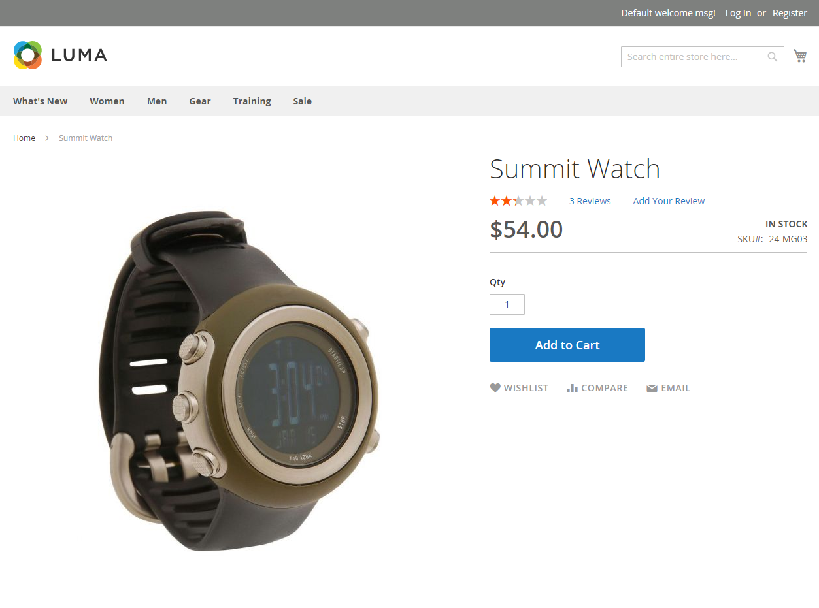

Simple Product

[**Step 1:** Choose the Product Type](javascript:void(0);)

|  |  |  |
| --- | --- | --- |
|  | **1.** | On the Admin sidebar, tap **Products**. Then, choose **Catalog**. |

|  |  |  |
| --- | --- | --- |
|  | **2.** | In the upper-right corner on the **Add Product** (  ) menu, choose **Simple Product**. |

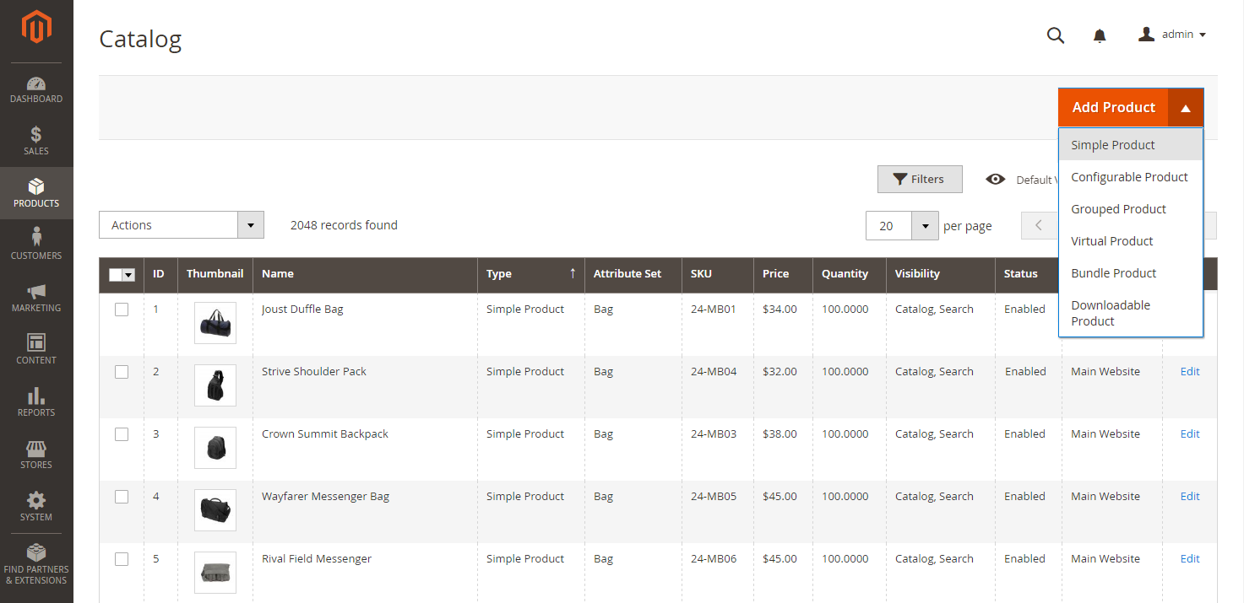   
Add Simple Product

[**Step 2:** Choose the Attribute Set](javascript:void(0);)

To choose the [attribute set](https://docs.magento.com/m2/ee/user_guide/stores/attribute-sets.html) that is used as a template for the product, do one of the following:

* In the **Search** box, enter the name of the [attribute](javascript:void(0);) set.
* In the list, choose the attribute set that you want to use.

The form is updated to reflect the change.

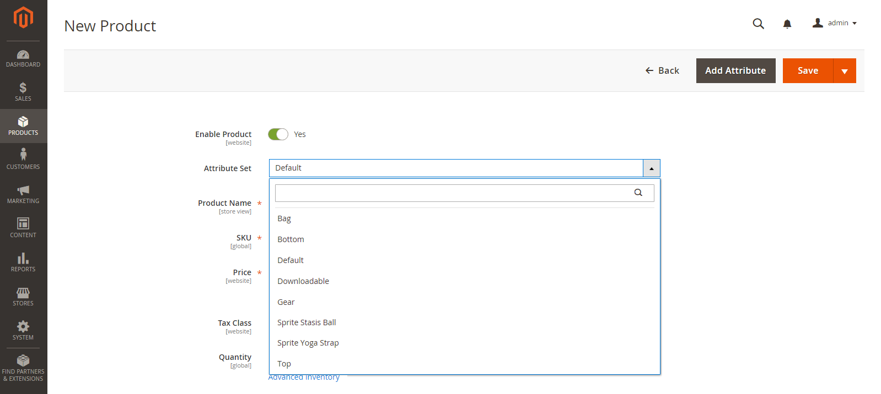   
Choose Attribute Set

[**Step 3:** Complete the Required Settings](javascript:void(0);)

|  |  |  |
| --- | --- | --- |
|  | **1.** | Enter the product **Product Name**. |

|  |  |  |
| --- | --- | --- |
|  | **2.** | Accept the default **SKU** that is based on the product name, or enter another. |

|  |  |  |
| --- | --- | --- |
|  | **3.** | Enter the product **Price**. |

|  |  |  |
| --- | --- | --- |
|  | **4.** | Because the product is not yet ready to publish, set the **Enable Product** switch to the “No”  position. |

|  |  |  |
| --- | --- | --- |
|  | **5.** | Tap  Save  and continue. |

When the product is saved, the [Store View](https://docs.magento.com/m2/ee/user_guide/catalog/product-scope.html) chooser appears in the upper-left corner.

|  |  |  |
| --- | --- | --- |
|  | **6.** | Choose the **Store View** where the product is to be available. |

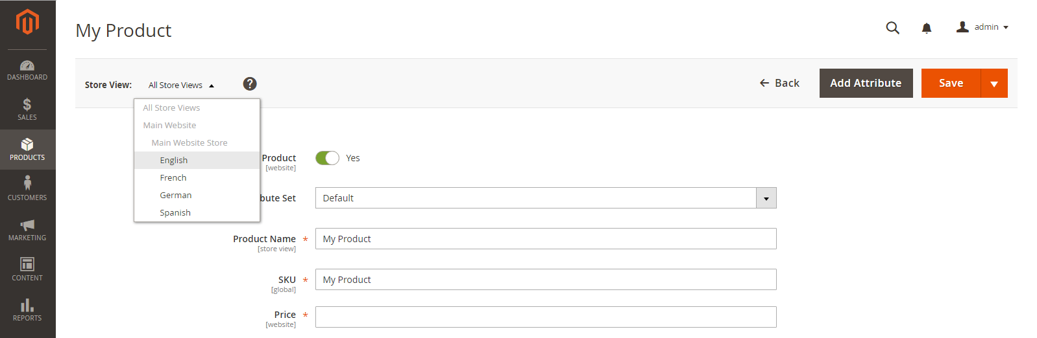   
Choose Store View

[**Step 4:** Complete the Basic Settings](javascript:void(0);)

|  |  |  |
| --- | --- | --- |
|  | **1.** | Set **Tax Class** to one of the following: |

* None
* Taxable Goods

|  |  |  |
| --- | --- | --- |
|  | **2.** | Enter the **Quantity** of the product that is currently in stock. |

Take note that by default, **Stock Status** is set to “In Stock.”

**Inventory Management:** If you enable [Inventory Management](https://docs.magento.com/m2/ee/user_guide/catalog/inventory-management.html), Single Source merchants set the quantity in this section. Multi Source merchants add sources and quantities in the Sources section. See [Assign Sources and Quantities (Inventory Management)](https://docs.magento.com/m2/ee/user_guide/catalog/product-create-simple.html" \l "inventory).

|  |  |  |
| --- | --- | --- |
|  | **3.** | Enter the **Weight** of the product. |

|  |  |  |
| --- | --- | --- |
|  | **4.** | Accept the default **Visibility** setting, “Catalog, Search.” |

|  |  |  |
| --- | --- | --- |
|  | **5.** | To assign **Categories** to the product, tap the **Select…** box. Then, do either of the following: |

Choose an existing category:

|  |  |  |
| --- | --- | --- |
|  | **a.** | Start typing in the box to find a match. |

|  |  |  |
| --- | --- | --- |
|  | **b.** | Mark the checkbox of each category that is to be assigned. |

Create a new category:

|  |  |  |
| --- | --- | --- |
|  | **a.** | Tap  New Category . |

|  |  |  |
| --- | --- | --- |
|  | **b.** | Enter the **Category Name** and choose the **Parent Category** to determine its position in the menu structure. |

|  |  |  |
| --- | --- | --- |
|  | **c.** | Tap  Create Category . |

|  |  |  |
| --- | --- | --- |
|  | **6.** | To feature the product in the list of [new products](https://docs.magento.com/m2/ee/user_guide/cms/widget-new-products-list.html), mark the **Set Product as New** checkbox. |

|  |  |  |
| --- | --- | --- |
|  | **7.** | Choose the **Country of Manufacture**. |

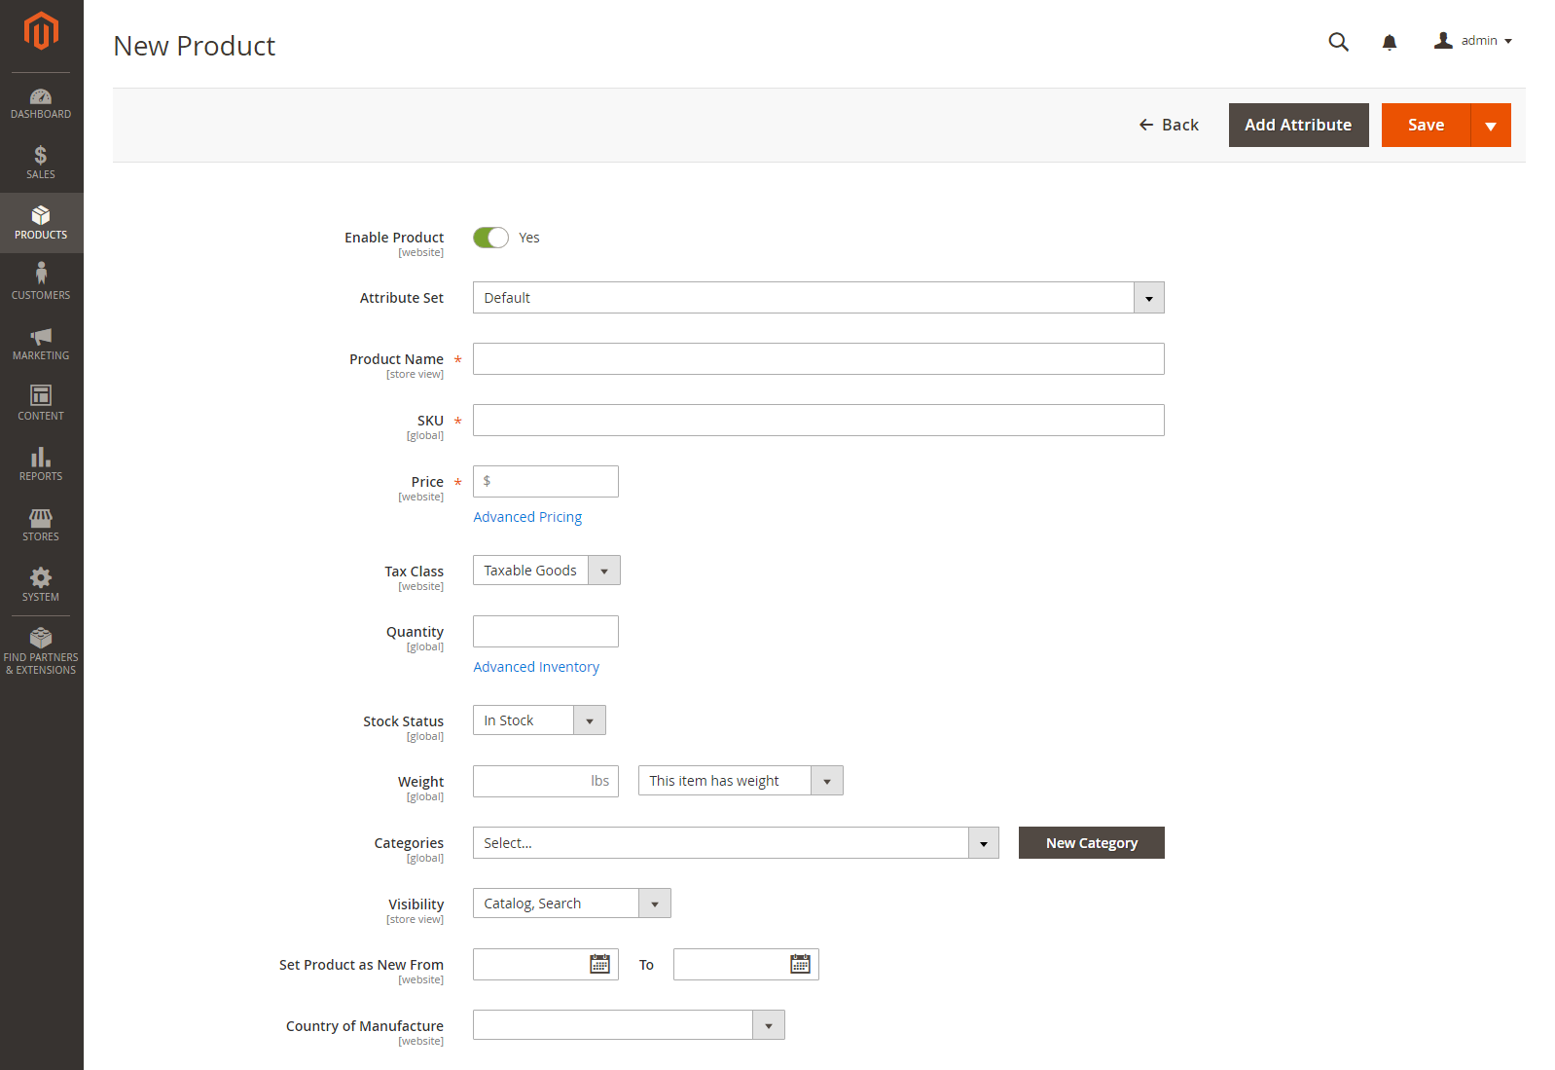   
Product Details

There might be additional individual attributes that describe the product. The selection varies attribute set, and you can complete them later.

 [Assign Sources and Quantities (Inventory Management)](javascript:void(0);)

For Multi Source merchants using Inventory Managenet, scroll down to the Sources section and assign sources and quantities:

|  |  |  |
| --- | --- | --- |
|  | **1.** | To add a source, tap **Assign Sources**. The Assign Sources page displays. |

|  |  |  |
| --- | --- | --- |
|  | **2.** | Browse or search for a source you want to add. Select the checkbox next to the source(s) you want to add for the product. |

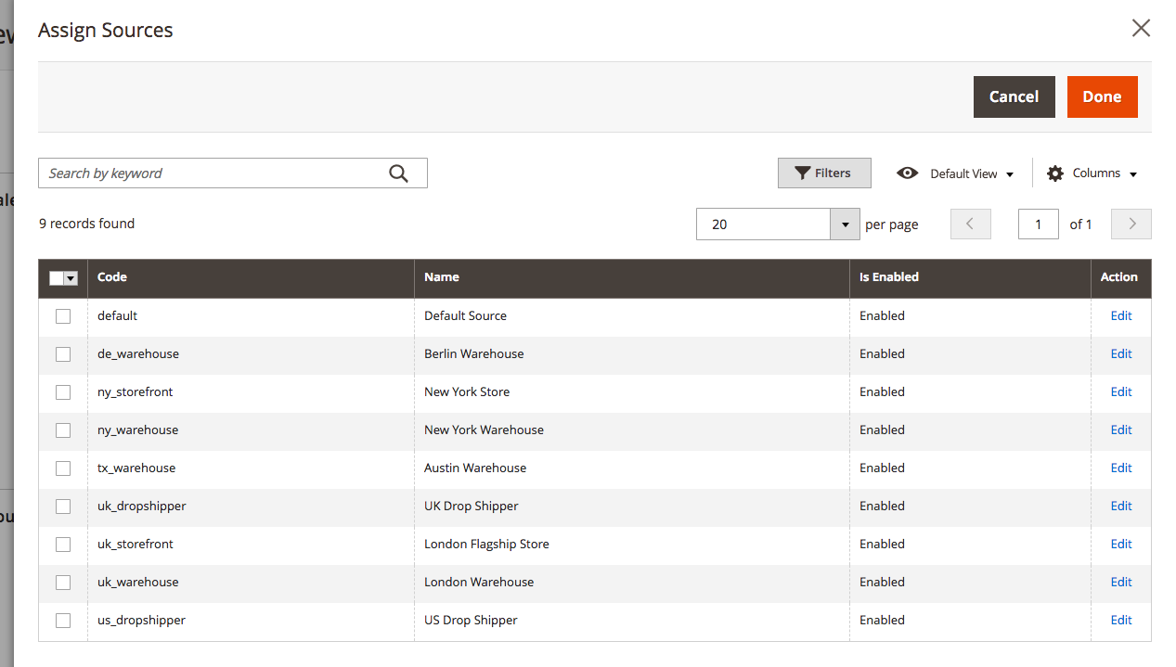   
Assign sources to the product

|  |  |  |
| --- | --- | --- |
|  | **3.** | Tap **Done** to add the sources. |

|  |  |  |
| --- | --- | --- |
|  | **4.** | To change settings and quantities per assigned source, do the following: |

|  |  |  |
| --- | --- | --- |
|  | **a.** | Set **Source Item Status** to In Stock. |

|  |  |  |
| --- | --- | --- |
|  | **b.** | Enter an amount update the **Qty** for on-hand stock. |

|  |  |  |
| --- | --- | --- |
|  | **c.** | To set a notification for inventory quantities, do one of the following: |

|  |  |
| --- | --- |
| Custom Notify Quantity | Clear the **Notify Quantity Use Default** checkbox and enter an amount in **Notify Quantity**. |
| Default Notify Quantity | Select the **Notify Quantity Use Default** checkbox. Magento checks and uses the setting in Advanced Inventory or global Store configuration. |

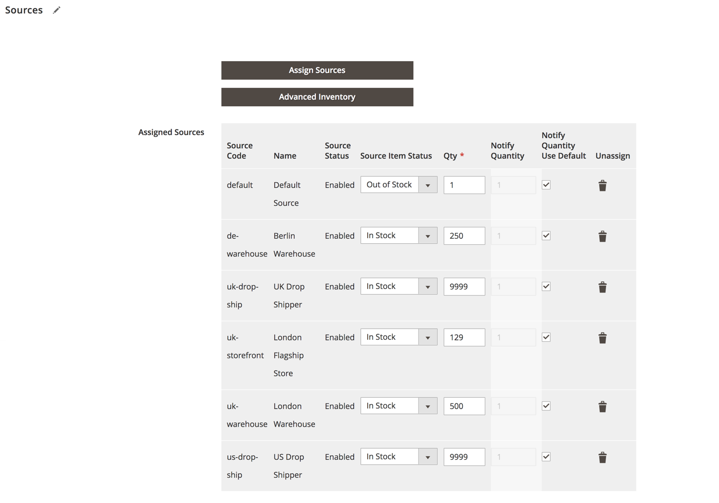   
Update Product Quantities per Source

[**Step 5:** Complete the Product Information](javascript:void(0);)

Scroll down and complete the information in the following sections as needed:

* [Content](https://docs.magento.com/m2/ee/user_guide/catalog/product-content.html)
* [Images and Videos](https://docs.magento.com/m2/ee/user_guide/catalog/product-images-and-video.html)
* [Related Products, Up-Sells, and Cross-Sells](https://docs.magento.com/m2/ee/user_guide/catalog/related-products-up-sells-cross-sells.html)
* [Search Engine Optimization](https://docs.magento.com/m2/ee/user_guide/catalog/product-search-engine-optimization.html)
* [Customizable Options](https://docs.magento.com/m2/ee/user_guide/catalog/settings-advanced-custom-options.html)
* [Products in Websites](https://docs.magento.com/m2/ee/user_guide/catalog/settings-basic-websites.html)
* [Design](https://docs.magento.com/m2/ee/user_guide/catalog/settings-advanced-design.html)
* [Gift Options](https://docs.magento.com/m2/ee/user_guide/catalog/product-gift-options.html)

[**Step 6:** Publish the Product](javascript:void(0);)

|  |  |  |
| --- | --- | --- |
|  | **1.** | If you are ready to publish the product in the catalog, set the **Enable Product** switch to the “Yes”  position. |

|  |  |  |
| --- | --- | --- |
|  | **2.** | Do one of the following: |

[**Method 1:** Save and Preview](javascript:void(0);)

[**Method 2:** Save and Close](javascript:void(0);)

Things to Remember

|  |  |
| --- | --- |
|  | Simple products can be included in configurable, bundle, and grouped product types. |
|  | A simple product can have custom options with a variety of input controls, which makes it possible to sell many product variations from a single SKU. |